http://rubinreports.blogspot.com/2009/12/obamas-watch-but-dont-see-tragic-fate.html?utm_source=feedburner&utm_medium=email&utm_campaign=Feed%3A+Rubinreports+%28RubinReports%29

Tuesday, December 15, 2009

The Obamas Watch But Don't See the Tragic Fate of Middle East Women: A Four-Picture Allegory
[Please subscribe for more original coverage of the Middle East, U.S. foreign policy, and other important stories]

By Barry Rubin

Turkey used to be a secular state striving for modernization and a place in the Western world. That dream is turning into a nightmare. The AKP regime, despite its pretense of being a center-right, family values, good government party, is moving Turkey toward Islamism. Washington and the West in general doesn't seem to notice though horrified Turkish secularists and liberals are yelling for help.

Look at the photos below of Prime Minister Tayyip Erdogan and his wife arriving in Washington to meet the Obamas. It's not so much that his wife, Ermine, is wearing a hijab (in Turkey called a turban) but look at her slumped over and self-effacing like a slave. I'm of no importance, is what her posture seems to say. Compare her abject stance to the three others in the picture standing tall and proud. In the first photo her sleeves are so long to conceal her hands that she can't even control them. Her head is slumped in a pose conveying submissiveness and shame at being a woman. And then in the fourth photo, she slinks off, like a servant who has been dismissed.

The sequence seems to symbollize the fate stalking Turkish woman, subverting the equality envisioned under the Ataturk republic to a status of servility and second-class citizenship. This holds true in much of the Muslim-majority countries and it is getting worse--Egypt and Iraq come to mind--not better.

Yet the Obamas don't even notice what's going on before their eyes. To them, Turkey is the very model of a moderate Muslim democracy, a good model to be encouraged rather than a NATO ally slipping steadily into the Iranian-Syrian alliance.

Take a look at those photos below and shiver.

But for sheer insanity there's this New York Times article. It celebrates the growing Turkish-Syrian alignment, claiming that this means Syria is becoming more moderate! The author actually states:

"For some [in Syria], the new closeness with secular, moderate Turkey represents a move away from Syria’s controversial alliance with Iran. For others, it suggests an embrace of Turkey’s more open, cosmopolitan society. And for many — including Syria’s president, Bashar al-Assad — it conjures different dreams of a revitalized regional economy, less vulnerable to Western sanctions or pressure."

Let me explain something. When a former ally joins your enemies you don't cheer about how your enemy is becoming your friend. Why should Turkey-Syria friendship mean Syria-Iran coolness, especially when Turkey and Iran are acting like great buddies? This article is just a pitiful parroting of Syrian disinformation. Shameful.
It isn't that Syria is aping a moderate pro-West Turkey but Turkey imitating an Islamist Iran. Want to see where Turkey is headed? Look at the photos below:

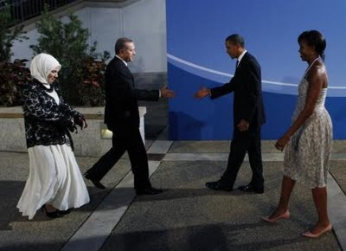

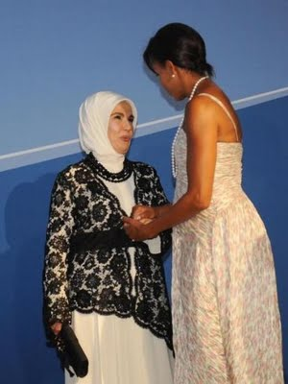

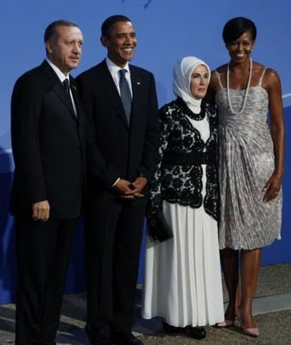

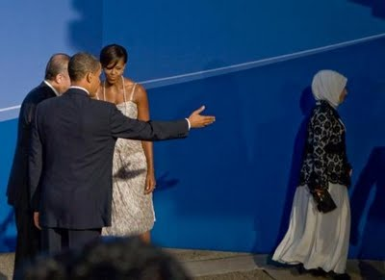
Barry Rubin is director of the Global Research in International Affairs (GLORIA) Center and editor of the Middle East Review of International Affairs (MERIA) Journal. His latest books are The Israel-Arab Reader (seventh edition), The Long War for Freedom: The Arab Struggle for Democracy in the Middle East (Wiley), and The Truth About Syria (Palgrave-Macmillan). To read and subscribe to MERIA, GLORIA articles, or to order books. To see or subscribe to his blog, Rubin Reports.
ShareThis
Posted by Barry Rubin at 10:15 PM
Labels: Turkey, women's status

